**Spetial Microphone**

Introduction: This would be an Android based mobile application.

First Approach: At the primitive approach, there would be two cellphones. One would act as a microphone broadcaster. Another one would act as a speaker output.

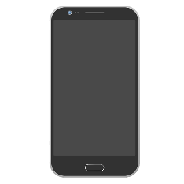 

Broadcaster Receiver

Microphone (BM) Speaker (RS)

Initially we will test with two android devices. When someone speaks at the BM side, the application would scan via Bluetooth/hotspot technology and automatically connect to the other device which would act as a speaker output. After the first test is successfully done, we would proceed with multiple devices on the RS side. In this case when someone speaks at BM side the application would scan for nearby devices and automatically connect to all of them simultaneously.